**Practice Problems for Midterm 2**

# #7, 8 (section 6.2)

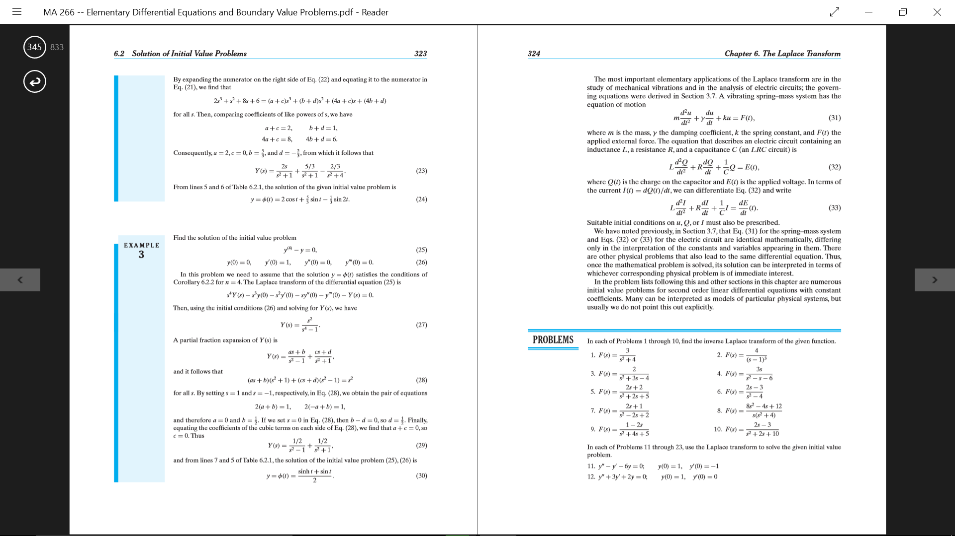

I will get a table for Laplace transforms. I feel pretty good about these, especially when I have the table. The biggest issue is just recognizing how to manipulate the equations to get the combinations of the Laplace transforms.

# #9, 11 (section 6.3)

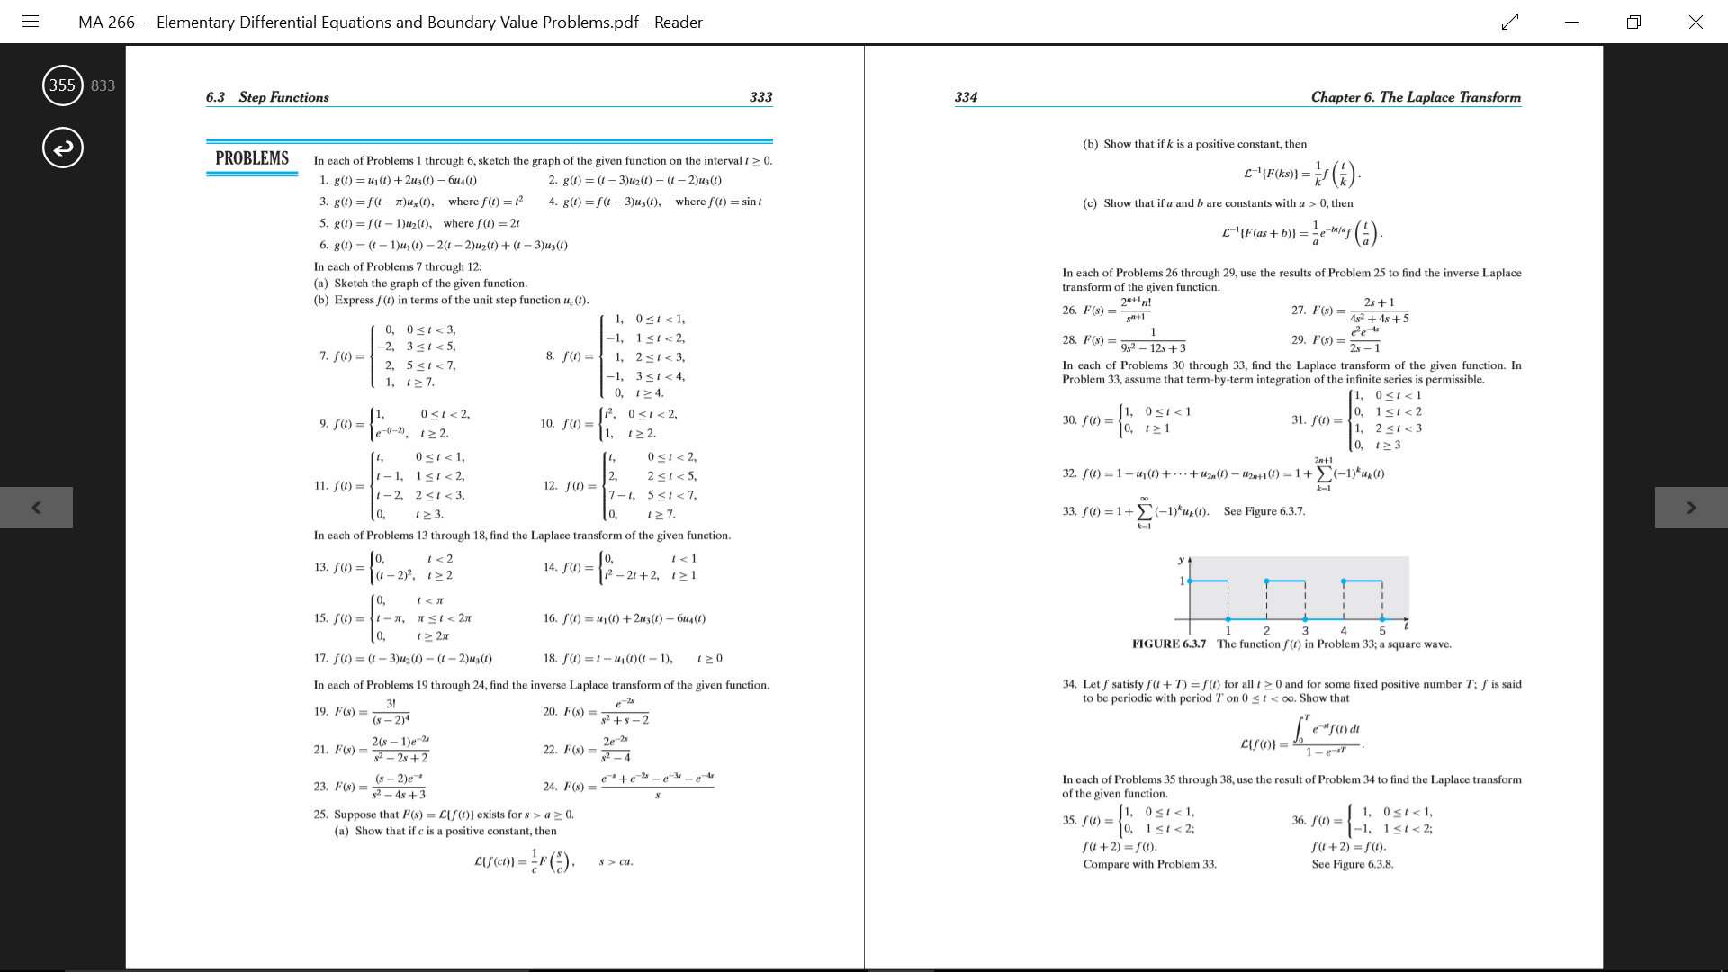



Kind of fuzzy on writing these in terms of the step functions, but with a few practice problems, I shouldn’t be too shabby.

Doing the practice now, I think I understand how to write the unit step function part except for when it comes to the last term, especially in number 11.

# #3, 9 (section 6.4)

# 

# 

# 

Definitely need work on these, especially drawing graphs.

# 

# 

# #3 (section 6.5)

# 

# 

Again, need work on these, especially drawing the graphs. For the most part, my professor uses a computer to draw the graphs in class and hasn’t said if we will need to draw them by hand or not yet.

# 

# 

# #4, 10 (section 6.6)

# 

___________________________________________________________________________

# 

The hardest parts of the convolution integral are remembering the formula and doing the actual integrations with rules from all the way back in calc 2.

# 

# 

# #3, 11 (section 7.5)

# ___________________________________

So describing the behaviors and drawing direction fields are where I need the most work. Other than that, I feel fine about finding eigenvalues and eigenvectors.

# 

# #3, 7 (section 7.6)

# ________________________________________

# 

So here the same issues as the previous sections, but also ~~I struggle with converting vectors with e^i terms into real-valued terms. I totally get it with regular functions, but for some reason vectors throw me off.~~

# 

# 

# #1, 8, 11 (section 7.8)

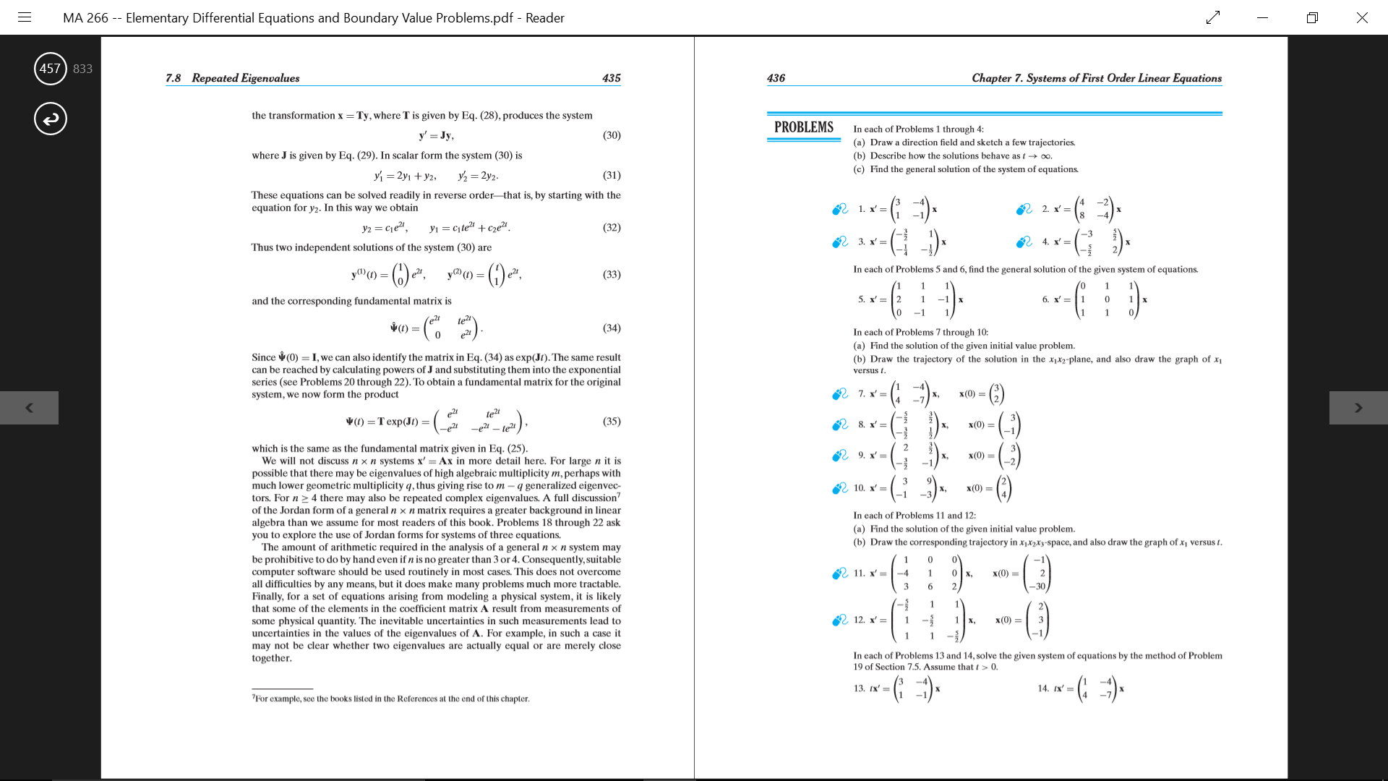_____________________________________________________________________________________________________________________________________________

Finding the nu vector went straight over my head. And again, drawing graphs and describing behaviors.